1. Compliance in Project Business

The [Project Business Excellence with the PM@Siemens methodology](https://intranet.for.siemens.com/wll/0103/en/Pages/pbe-pm-guide.aspx) is the company-wide standard for project management developed in coordination with the Organizational Units. It defines the tasks, responsibilities and fundamental processes in project management and for project business.

It addresses all important areas of Siemens’ project management and describes the expectations for excellent project business across the entire life cycle, including the mandatory minimum requirements that must be met during acquisition and execution.

The [Limits of Authority (LoA)](https://intranet.for.siemens.com/wll/0103/en/Pages/pbe-loa.aspx) process is part of the PM@Siemens methodology. It defines when and at what level management decisions are required. It improves the quality of decision-making in the bidding phase (bid/no-bid) for each individual project.

Compliance in Project (CiP) mainly addresses Limits of Authority (LoA) project types [Solution Business (LoA); Service Business (LoA)] with Compliance specific risks especially regarding [Anti-Corruption](https://webbooks.siemens.com/public/LC/chen/index.htm?n=Part-1-Activity-Fields,A.-Anti-Corruption), [Anti-Money Laundering](https://webbooks.siemens.com/public/LC/chen/index.htm?n=Part-1-Activity-Fields,C.-Anti-Money-Laundering-(AML)) and [Human Rights](https://webbooks.siemens.com/public/LC/chen/index.htm?n=Part-1-Activity-Fields,E.-Human-Rights)

The Compliance in Projects (CiP) handbook chapter aims to ensure appropriate identification of risks during the pre-sales, sales and execution phase and adequate mitigation of these risks.

|  |
| --- |
| General principles:  Projects must comply with the Siemens-internal regulations as well as the applicable local laws during the:  Pre-sales phase   * + For an early identification and mitigation of Compliance risks in the pre-sales phase, it is recommended to establish a regular dialogue between sales personnel and the Compliance Officer (CO) where potential Compliance risks are assessed and mitigated as early in the process as possible (pre-sales risk assessment)   Sales phase   * + A LoA Compliance Risk Evaluation (LoA CRE) is the core element of Compliance in the sales phase. A LoA CRE is part of the [PM@Siemens LoA Tool](https://loa.cf.siemens.de/loa/faces/jsf/home.xhtml) which supports the identification of Compliance risks.   Execution phase   * + The identification of Compliance risks and mitigation during the project execution phase lies within the overall responsibility of the Project Manager of the execution phase (PM execution) with support from the responsible Compliance Officer.   The Siemens Project Manager[1] is overall responsible ensuring appropriate identification and mitigation of Compliance risks throughout the entire project lifecycle.  The responsible Compliance Officer will support the Project Manager whenever needed[2]. He has to be involved according to [PM Guide](https://intranet.for.siemens.com/wll/0103/en/Pages/pbe-pm-guide.aspx)[3]  Any Compliance concern arising throughout the project lifecycle must be communicated immediately to the responsible sales or project manager[4] and the Compliance Officer (CO)[5].  Export control related risks are covered by the existing export control processes. |

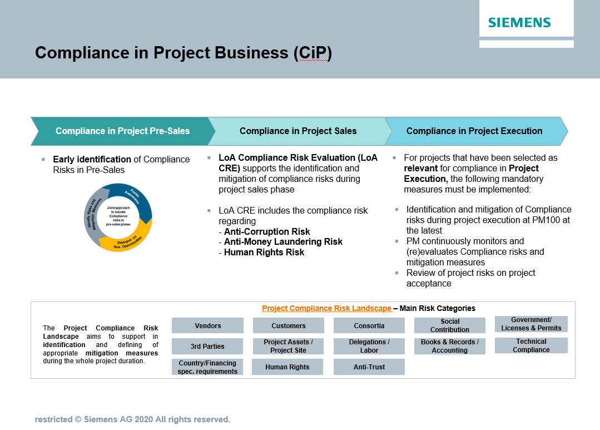

## Compliance in pre-sales

Already while developing a business opportunity (pre-sales), it is possible that un-identified or un-mitigated Compliance risks may lead to violations of applicable law.

Potential violations may also occur prior to entering the Limits of Authority (LoA) process.

|  |
| --- |
| General principles:  For an early identification and mitigation of Compliance risks in the pre-sales phase, it is recommended to establish a regular dialogue between sales personnel and the CO where potential Compliance risks are assessed and mitigated as early in the process as possible (pre-sales risk assessment)  This concept can be adapted in a risk-oriented manner by the Businesses/Countries.  It is very important that a risk which may occur in pre-sales is identified, and appropriately mitigated.  Further guidance on risk identification in the pre-sales phase is available [here](https://intranet.for.siemens.com/cms/059/en/processes/publications/Pages/compliance_project-management.aspx). |

A **pre-sales risk assessment** for business opportunities with an expected bid-volume exceeding €2,500,000 should focus on the following (examples but not limited to), if these risk areas exist

* Legally binding commitments without a step-out clause
* Involvement of 3rd parties to influence a project
* Projects that raise the potential for a competition or antitrust risk situation (e.g. consortium with a competitor or a parallel bid by Siemens)
* Risks associated to consortiums
* Projects with [AML Red Flags (chapter C 1)](https://webbooks.siemens.com/public/LC/chen/index.htm?n=Part-1-Activity-Fields,C.-Anti-Money-Laundering-(AML),1.-AML-Red-Flags)
* Risks related to [human rights violations](https://webbooks.siemens.com/public/LC/chen/index.htm?n=Part-1-Activity-Fields,E.-Human-Rights,6.-Toolbox,6.6.-Risk-factors/areas)
* Financing projects
* Projects with partners located in countries with increased export control risks
* Cost sharing with partners
* Highly complex business cases

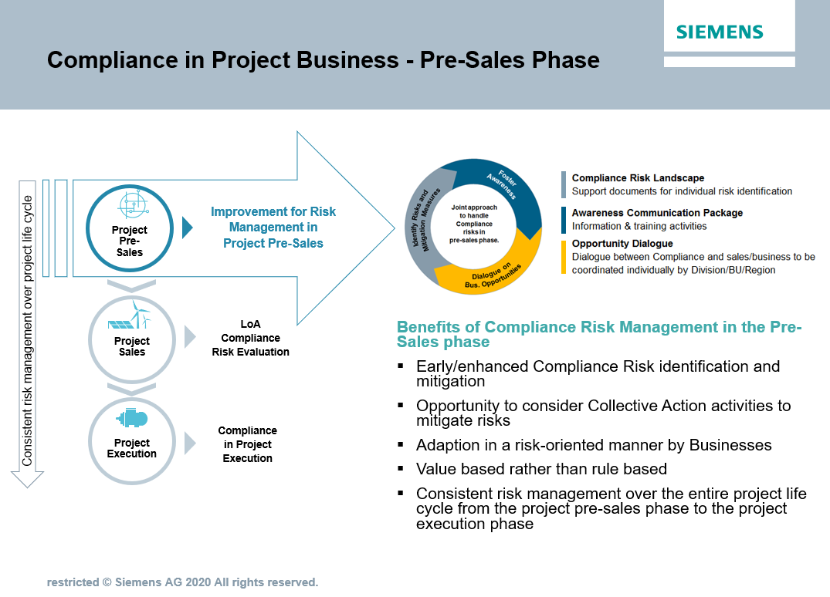

## 1.2. Compliance in project sales

Many Compliance risks occur during the sales phase. Also, Compliance matters that occur during project execution often originate from the sales phase.

|  |
| --- |
| General principles:  A LoA Compliance Risk Evaluation (LoA CRE) is the core element of Compliance in the sales phase. The LoA CRE is part of the PM@Siemens [LoA Tool](https://loa.cf.siemens.de/loa) which supports the identification of Compliance risks.  Further guidance on risk identification is available in the [Project Compliance risk landscape](https://findit.compliance.siemens.com/content/10000102/Compliance/LC_CO/LC_CO_PT_CO_CiP/findIT_LC_CO_PT_CO_CiP_2654.pdf). |

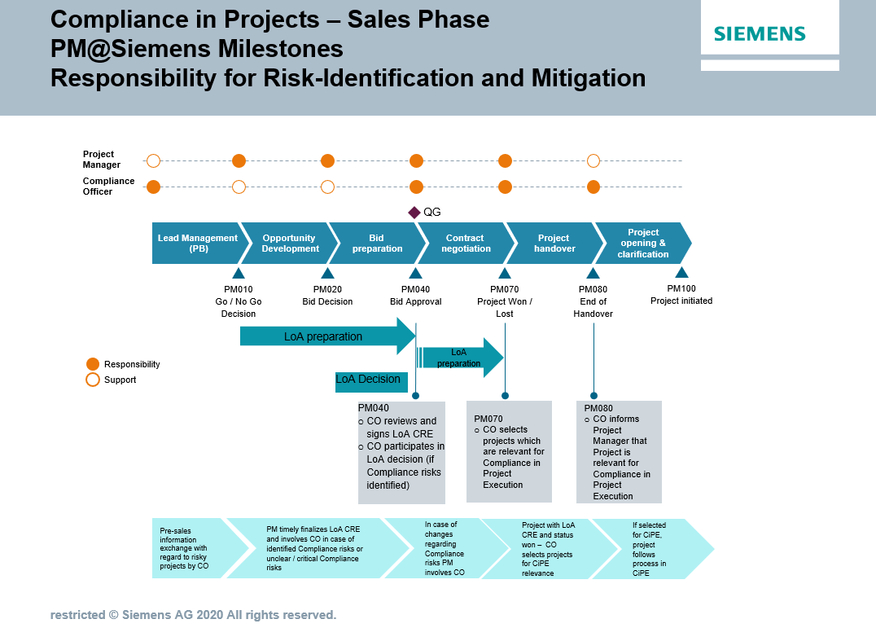

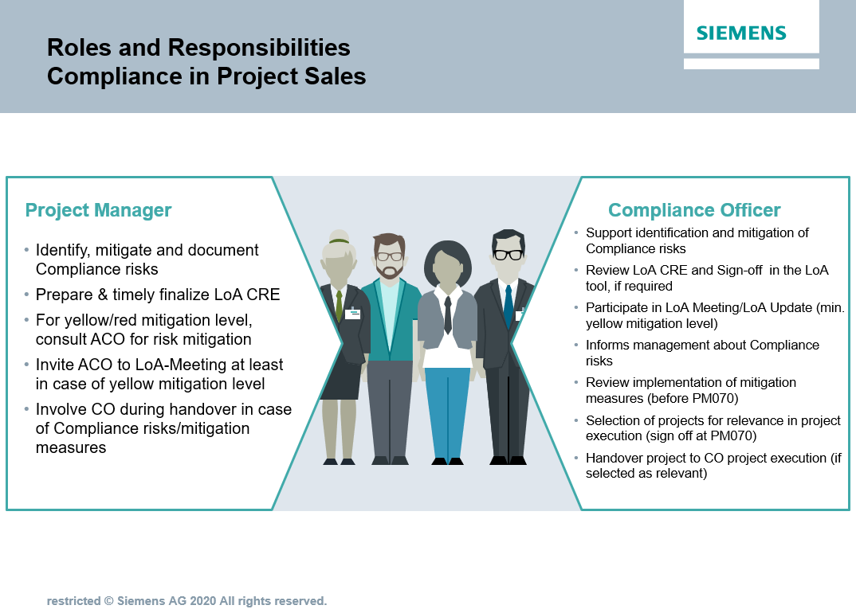

### 1.2.1. Projects in scope for LoA CRE

A risk-based LoA CRE is required for all projects (and sub-projects) that are subject to the LoA (Limits of Authority) process with a total order volume (planned revenue) of more than € 2,500,000 and that fulfill **at least one of the following criteria**:

* Project category A/B or
* Business Partner involvement (according to [Compliance Handbook, A 3 Cooperation with Business Partners](https://webbooks.siemens.com/public/LC/chen/index.htm?n=Part-1-Activity-Fields,A.-Anti-Corruption,3.-Cooperation-with-Business-Partners)) or
* Customer / execution country is a [TI/CPI high risk country](https://findit.compliance.siemens.com/content/10000101/Compliance/LC_CO/LC_CO_STR_RM/findIT_LC_CO_STR_RM_8266.pdf)[6] which is different from the country of the Siemens entity[7] (ARE country) or
* Projects backed by a "national export credit guarantee" or financed wholly or partly by multilateral development banks or multilateral financial institutions[8] or
* Nominated major vendor involved[9] or
* Project execution country is a   
  a. [Human Rights extreme risk country](https://findit.compliance.siemens.com/content/10000101/Compliance/LC_CO/LC_CO_STR/findIT_LC_CO_STR_6394.xlsx) and the project category is A/B/C; or  
  b. [Human Rights high risk country](https://findit.compliance.siemens.com/content/10000101/Compliance/LC_CO/LC_CO_STR/findIT_LC_CO_STR_6394.xlsx) and at least one of the following criteria is fulfilled:  
   - Project category A/B or   
   - the project category is C and as consortium partner or major vendor is involved or

1. [Human Rights extreme or high risk country](https://findit.compliance.siemens.com/content/10000101/Compliance/LC_CO/LC_CO_STR/findIT_LC_CO_STR_6394.xlsx) and the project involves an Export credit guarantee, Multilateral Development Bank or Multilateral Financial Institutions involved.

Furthermore this applies also for every project with a volume ≤ € 2,500,000 with the involvement of export credit guarantee, multilateral development banks, or multilateral financial institutions.

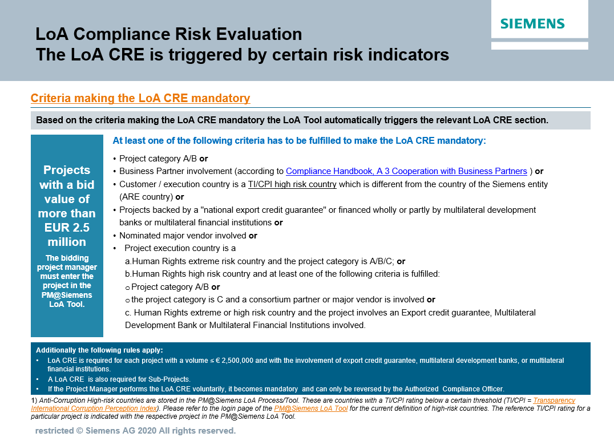

### 1.2.2. Identification & mitigation of Compliance risks

The LoA CRE’s purpose is to identify and document Compliance relevant risks and to define corresponding mitigation measures during the Siemens sales process up to PM040/PM070. Compliance risks are determined during the LoA CRE, approved and signed by the CO at PM040/PM070 and are included in the LoA risk report and Compliance risk summary for the LoA decision.

The authorized project manager (sales phase) with support from the CO is responsible for the identification and mitigation of applicable Compliance risks. A LoA CRE is mandatory for all projects meeting the criteria in chapter [H 1.2.1](https://webbooks.siemens.com/public/LC/chen/index.htm?n=Part-2-Business-Perspective,H.-Compliance-in-Business-Processes-and-Projects,1.-Compliance-in-Project-Business,1.2.-Compliance-in-project-sales,1.2.1.-Projects-in-scope-for-LoA-CRE). of this document and with final review performed by the Authorized Compliance Officer (ACO) before the final LoA decision.

The “Compliance Summary[10]” provides a comprehensive overview on Compliance relevant information and will be archived in the PM@Siemens.

### 1.2.3. LoA CRE preparation by APM

Depending on the data provided in the “key data” section of the LoA, additional information may be required from the authorized project manager (APM). This documentation/evidence (e.g. results of internet searches, company information with regard to third parties, vendors, consortium partners, confirmations received by legal, contract management, and/or project commercial) must be included with the project documentation and made available to the CO. A Compliance risk class is automatically defined.

The CO must have access to any Compliance related information in any project within his area of responsibility and participates in the decision process as defined in [circular No. 182 “Limits of Authority (LoA) Process and Project Approvals”](https://circulars.siemens.com/content/circulars/ca/_layouts/querplex/circularapplication/documents/CircularDownload.aspx?ID=SC_182.pdf#page=4).

### 1.2.4. LoA CRE – review and sign-off by ACO

The APM initiates the LoA sign-off workflow, which triggers an automated email to notify the ACO. The ACO then reviews and clarifies the provided information and involves the CO of the respective escalation level[11] (e.g. in cross border projects) to ensure comprehensive coverage of all Compliance risks.

Mitigation measures[12] are documented by the APM and ACO in the LoA CRE and are part of the LoA risk report. This includes identifying risks, mitigation steps; persons assigned the implementation measures and timelines/due dates. During the sign-off the ACO may comment on Compliance relevant topics and add potential conditions for approval and measures to mitigate Compliance risks.

Ideally, the agreed upon mitigation efforts should be implanted no later than the PM070 stage by the APM. Nevertheless, any measures and action items not completed shall be handed over and be dealt with during project execution phase.

Note: If any identified risk has a status of RED before the LoA decision, PM040 bid approval will not be possible

### 1.2.5. LoA decision / LoA update

If any identified risks have a status of YELLOW before the LoA decision, the ACO must participate in the LoA decision.

Management is informed about Compliance risks and proposed mitigation measures before LoA decision. An adequate level of Compliance risk clarification and mitigation has to be achieved by the involved parties. This ensures a sound basis for management decision.

The LoA Update is performed according to [circular No. 182 “Limits of Authority (LoA) Process and Project Approvals”](https://circulars.siemens.com/content/circulars/ca/_layouts/querplex/circularapplication/documents/CircularDownload.aspx?ID=SC_182.pdf#page=4) and the CO participates if required.

### 1.2.6. Handover to project execution

If more than one Compliance Officer is involved in the project (e.g. for cross border projects) they should discuss the comprehensive risks identified for the project and align on further cooperation during the project execution phase starting with PM080.

## Compliance in project execution

|  |
| --- |
| General principles:  Compliance in the project execution phase (CiPE) applies to all projects selected by the Authorized Compliance Officer (ACO) as relevant to the project execution phase. The relevance selection by the ACO must be documented in the LoA tool during the sign-off process at the milestone PM070 for all projects with LoA CRE and won status.  If the ACO decides that a project is relevant for CiPE, then the resulting steps and activities are mandatory for the PM responsible during execution phase.  The CiPE process starts with PM100.  Irrespective whether a project is subject to the CiPE process or not, the identification of Compliance risks and mitigation during the project execution phase lies within the overall responsibility of the PM execution with support from the responsible CO. |

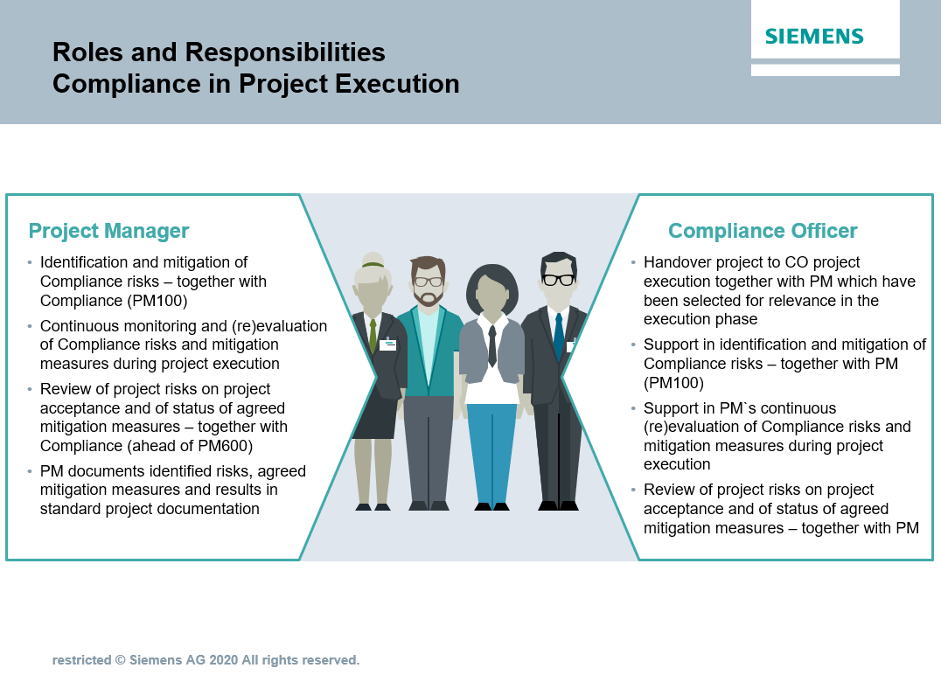

### 1.3.1. Selection of projects for CiPE

For any Siemens project with LoA CRE and status won the ACO decides about the CiPE relevance of the project as a mandatory risk mitigation measure.

The selection of CiPE relevant projects is a mandatory process step at the sign off process at milestone PM070 in the PM@Siemens LoA tool.

If the ACO decides that a project is relevant for CiPE, then the resulting steps and activities are mandatory for the PM responsible during execution phase.

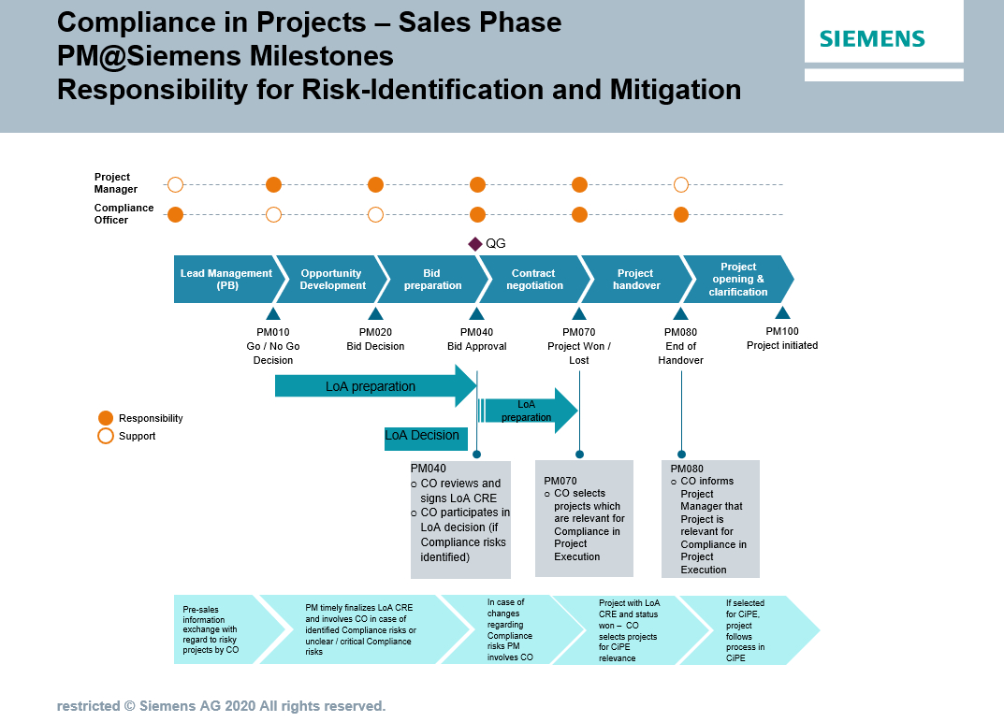

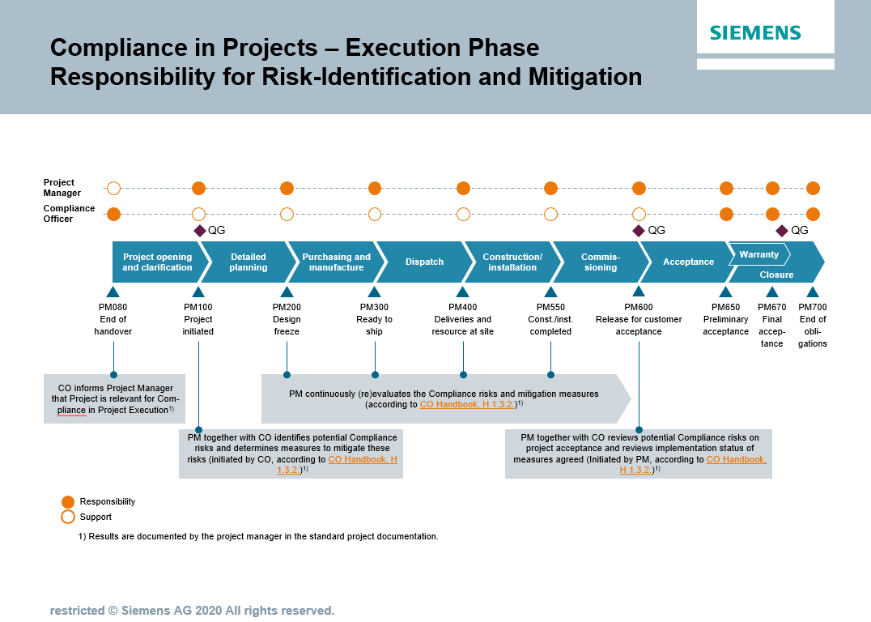

The PM should involve the ACO at any time during the project’s execution phase for matters related to risk analysis and mitigation. During the project execution phase a project can be selected at any time as relevant for Compliance in project execution. It is in the discretion of the Compliance Officer to decide whether a project is relevant for the execution phase or not.

If the selection is made after PM100, the meeting specified in H 1.3.2.1.must be held without delay. The meeting minutes should include the result of the review and must be included in the standard project documentation by the PM.

Potential reasons which could lead to select a project as relevant for CiPE (after PM080) as a mandatory mitigation measure during the project execution phase can be for example:

* Compliance concerns made by the PM/CEO/CFO/Responsible Business Manager during project execution
* Business Partner[13] shows increased risks (high-risk BP, BP "under observation", etc.)
* Customer demands the involvement of a specific subcontractor or intermediary without plausible justification
* Risks or concerns raised as a result of an internal or external audit
* Compliance investigation mandate related to the project
* AML Red Flags ([chapter C 1](https://webbooks.siemens.com/public/LC/chen/index.htm?n=Part-1-Activity-Fields,C.-Anti-Money-Laundering-(AML),1.-AML-Red-Flags)) arises

### 1.3.2. Measures for the identification and mitigation of Compliance risks

For projects selected as relevant for Compliance in project execution according to this handbook chapter, the following measures are mandatory.



#### 1.3.2.1. Measures and process at the start of the project execution phase (PM100)

Compliance risks and agreed upon measures for mitigation are documented in the project documentation according to PM@Siemens.

Compliance Meeting

The responsible CO initiates a meeting[14] with the PM at the start of the project execution. (If the project is designated after PM100, this meeting must be held without delay).

The Compliance meeting should occur as follows:

* Compliance relevant risks during the project execution phase should be identified and if applicable, it should be started to define measures to mitigate these risks. (These measures may include collective action activities such as Compliance and integrity pacts in consortia or special purpose vehicles).
* The [Project Compliance Risk Landscape](https://findit.compliance.siemens.com/content/10000102/Compliance/LC_CO/LC_CO_PT_CO_CiP/findIT_LC_CO_PT_CO_CiP_2654.pdf) can be used to support the risk analysis.
* To ensure the project adheres to local country Compliance requirements, the local CO of the project`s location should also be involved.

Results/Monitoring

The PM will include the results (e.g. risk mitigation measures, names of responsible persons, and timelines/due dates) of this meeting in the project documentation

#### 1.3.2.2. Continuous monitoring and revaluation by PM

The PM regularly monitors whether the Compliance risks identified at the start of the project execution phase still exist or whether they have changed. This is done both ad-hoc and in line with the regular risk management cycle for projects.

If a new Compliance related risk arises or an existing risk changes (or no longer applies), the PM notifies the CO and responsible business manager for agreement on adequate mitigation measures.

The PM also regularly checks that the agreed upon mitigation measures are effective or still adequate and adjusts the measures accordingly if required.

Results/Monitoring

The PM provides evidence of the completed Compliance measures in the project documentation. The PM also provides the results of the evaluation in the standard “Q-Gate” documentation and informs the responsible CO.

#### 1.3.2.3. Review of project risks on project acceptance (PM600)

Prior to the PM600, the PM initiates a mandatory discussion with the responsible CO. The purpose of this meeting is to review the risk analysis H 1.3.2.1. with regard to the upcoming project’s acceptance and define additional mitigation measures when necessary. Particularly emphasis should be on the acceptance tests and decision-making process within the customer acceptance framework.

At least the following topics[15] should be covered:

* Is there any indication that an employee of the customer will demand an unjust advantage (e.g. cash payment or other benefit) in exchange for signing the customer acceptance documents?
* Is there any indication that an employee of the customer will demand and unjust advantage for proceeding with the customer acceptance even though the technical specifications or test results do not yet fulfill Siemens’ contractual obligations?
* Is there any indication that an employee of the customer is deliberately delaying the acceptance preparations for no valid reason and is demanding an unjust advantage in exchange for ending the delays?
* Is there any scrap or excess material left over that could be misused to create slush funds or otherwise used inappropriately?

In addition, the PM and responsible CO will perform a final check with regard to the implementation of previously defined mitigation measures.

Result/Monitoring

The PM will include the result of the review in the meeting minutes and the final evidence of the Compliance measures in the project documentation at PM650.

#### 1.3.2.4. Further measures

At any time during the project execution, the PM and responsible CO can define further joint measures in the addition to the activities in sections H 1.3.2..

## Factors for the selection of projects for CiPE

|  |  |  |
| --- | --- | --- |
|  | Criteria | Explanation |
| 1. | Projects with project category “A” | *The project categorization is determined in the PM@Siemens LoA Tool.* |
| 2. | Projects with anti-corruption risk  class 1 or 2 | *The anti-corruption risk class is determined in the PM@Siemens LoA Tool.* |
| 3. | Projects in high-risk countries outside the entity's own country | *Siemens Compliance country ratings (TI/CPI) is ≤ 42 and minimum one of the execution countries differs from the ARE country of the responsible Siemens entity (signing party). The Siemens Compliance Corruption country rating (TI/CPI) is stored in the PM@Siemens LoA Tool[16]".* |
| 4. | Projects with Anti-Money Laundering Red Flags (AML Red Flags) | *AML Red Flags are described in* [*chapter C1*](https://webbooks.siemens.com/public/LC/chen/index.htm?n=Part-1-Activity-Fields,C.-Anti-Money-Laundering-(AML),1.-AML-Red-Flags) |
| 5. | Projects backed by a "national export credit guarantee" or financed wholly or partly by multilateral development banks or multilateral financial institutions | *A definition of the relevant financial institutions is given in the PM@Siemens LoA Tool. The applicability is also determined there.* |
| 6. | Business Partners with red flags and BP CDDs[17] "under observation" | *The project involves a Business Partner that is currently designated as "under observation" in the NextGen BPC-Tool (Business Partner Compliance tool) or to which red flags have been assigned.*  *The current categorization of the Business Partner is stored in the NextGen BPC-Tool (Business Partner Compliance tool).* |
| 7. | Suspicious behavior of the customer in the selection of a subcontractor or intermediary | *The customer issued an instruction for a subcontractor or intermediary (distributor or system integrator, for example) to be involved in the project without plausible justification.* |
| 8. | Projects attracting a high level of public attention[18] | *Circumstances under which designation can be required in individual cases include for example:*   * *Infrastructure project with interregional importance* * *"Construction progress pressure" due to public attention (e.g. Berlin airport, Metro Ryad)* * *Complex projects/megaprojects* * *High level of media attention.* |
| 9. | External consortium (open and silent consortium) | *Siemens is involved as a consortium partner in an open or silent consortium.* |
| 10. | Projects for which unusual/unclear contractual agreements have been made with the customer regarding travel, FAT, accommodation, daily allowances, social responsibility | * *Unusual agreements relate, for example, to daily allowances that are inadequate, e.g. that differ significantly from the amounts agreed in comparable cases / exceed adequate usual local travel costs.* * *Unclear agreements are contractual terms that are ambiguous regarding the purpose of such trips or that grant the customer an extensive right to determine the justification for such trips, which customer employees should take part, or the class of air tickets/hotels to be reserved or other reimbursements without a legitimate business purpose.* * *Siemens involvement in "social responsibility" measures (sponsoring and donations or other contributions).* |
| 11. | No Compliance organization in the country of project execution[19] | * *There is no local Siemens Compliance organization in the country where the project is being implemented.* * *Compliance activities are controlled or implemented from the Business and/or from regional Compliance organizations in other countries.* |
| 12. | Compliance "preconditions" for project execution are already defined in the sales phase (e.g. LoA decision). | * *Compliance risks were identified during the LoA Compliance Risk Evaluation, and corresponding mitigation measures defined (LoA Tool Risk Report).* * *The agreed mitigation measures have either not been implemented or are scheduled for implementation during the project execution phase.* |
| 13 | Projects with Human Right risks | * *Projects with ECA/IFI involvement* * *Projects with indications/evidence of protest or controversies (especially in case of allegations of human rights violations raised through protesters)* * *Projects in conflict affected project execution countries (incl. pre- and post-conflicts)* * *Projects requiring more than small scale land acquisition or relocation of (members of) communities e.g. by customer or end-customer* * *Projects with indications/evidence of impacts on indigenous communities/peoples* * *Projects with major civil or construction work in scope of Siemens or a Siemens consortium partner* * *Projects with a project execution country having an extreme human rights risk country rating* |

## Training and supporting material

▌ [Compliance in Project Business Intranet](https://intranet.for.siemens.com/cms/059/en/processes/publications/Pages/compliance_project-management.aspx)

▌ [Collaboration in innovation projects one-pager](https://findit.compliance.siemens.com/content/10000101/Compliance/LC_CO/LC_CO_DF/findIT_LC_CO_DF_9125.pdf)

▌ [Collaboration in innovation projects Compliance checklist](https://findit.compliance.siemens.com/content/10000101/Compliance/LC_CO/LC_CO_DF/findIT_LC_CO_DF_9127.xlsx)

▌ [Compliance in innovation projects training slides](https://findit.compliance.siemens.com/content/10000101/Compliance/LC_CO/LC_CO_DF/findIT_LC_CO_DF_9124.pdf)

## History of changes

|  |  |  |
| --- | --- | --- |
| **Date** | **Author** | **Major changes of binding content** |
| May 8, 2013 | Wolfgang Raschka (CT CSG PM PE)  Martin Felkl (CL CO-O BE) | * First Version Guidance Compliance in Project Execution |
| April 1, 2017 | Uwe Breitenstein (LC CO GR RM) | Project Execution   * Update criteria for identification of relevant projects * Implementation new process * Definition of roles and responsibilities |
| November 1, 2017 | Uwe Breitenstein (LC CO GR RM) | Project Sales   * First Version “Guidance Compliance in Project Sales” |
| May 1, 2018 | Uwe Breitenstein (LC CO GR RM) | * Consolidation of the existing guidances “sales” and “execution” into one directive “Compliance in Projects” * Implementation “Pre-Sales” |
| October 1, 2020 | Ute Stach  (LC CO PT CO) | * Implementation of CMC decision (February 2020/August 2020) regarding Compliance in Project Execution (CiPE) * Discontinue the mandatory use of the [criteria used to identify projects in scope of the Compliance in Project Execution process](https://webbooks.siemens.com/public/LC/chen/index.htm?n=Part-2-Business-Perspective,H.-Compliance-in-Business-Processes-and-Projects,1.-Compliance-in-Project-Business,1.3.-Compliance-in-project-execution,1.3.1.-Projects-in-scope). * Instead, the responsible Compliance Officer selects projects which are relevant for the project execution process as a mandatory risk mitigation measure during the PM070 sign-off or at any point during the project execution lifecycle. |
| April 1, 2021 | Peter Lohse  (LC CO DI) | * New supporting documents for “Collaboration in innovation projects” |

## 1.7. Contacts

Compliance Officer

The Compliance Officer responsible for your unit can be found through the following [link](https://intranet.for.siemens.com/cms/059/en/about/org/Pages/compliance_organization.aspx).

Corporate Governance Owner

[Ralph Nohe (LC CO PT CO)](https://soc.siemens.cloud/profile/Z000FA6G)

1. Bid manager, authorized project manager (sales phase) and execution project manager.
2. According to [circular No. 182 “Limits of Authority (LoA) Process and Project Approvals”](https://circulars.siemens.com/content/circulars/ca/_layouts/querplex/circularapplication/documents/CircularDownload.aspx?ID=SC_182.pdf#page=4)
3. In line with the latest version
4. The Authorized Project Manager should inform the responsible Business Manager if applicable.
5. The Compliance Officer should be the Compliance Officer for the respective Business (e.g. unit), for example the ACO (Authorized Compliance Officer as defined in the PM@Siemens LoA Tool), the mandated Compliance Officer (e.g. operational Compliance Officer) or the Country Compliance Officer or a nominated representative.
6. Anti-Corruption High-risk countries are stored in the PM@Siemens LoA Tool. Transparency International publishes the Corruption Perception Index (TI/CPI). Based on these ratings (average over the past two years) and a risk evaluation by LC CO, the Compliance Country Ratings (low/medium/high) have been prepared.
7. Siemens entity that signs the contract with the customer. In the PM@Siemens LoA Tool this is indicated as the “ARE country” (ARE = Abrechnungseinheit).
8. Only the institutions listed in the PM@Siemens LoA Process Tool (Section Key Data) need to be considered.
9. A Nominated major vendor is any external company/firm that supplies goods, carries out work, performs services or supports Siemens in any other way (including all kind of subcontractors, sub suppliers and suppliers/manufacturers etc.) which is mandatorily required by the customer or any third party without choice or technically understandable reason for single sourcing in regard to a certain LoA, if the Businesses specific threshold for share of volume and value of order apply.
10. Compliance Risk Summary provides an overview of project relevant information, compliance relevant risks and defined mitigation measures.
11. Escalation level according to [circular No. 182 “Limits of Authority (LoA) Process and Project Approvals”](https://circulars.siemens.com/content/circulars/ca/_layouts/querplex/circularapplication/documents/CircularDownload.aspx?ID=SC_182.pdf#page=4)
12. The mitigation measures could also include appropriate Collective Action activities such as Compliance and Integrity Pacts in Consortia.
13. according to [Compliance Handbook A 3](https://webbooks.siemens.com/public/LC/chen/index.htm?n=Part-1-Activity-Fields,A.-Anti-Corruption,3.-Cooperation-with-Business-Partners,3.2.-Business-Partner-Categorization)
14. The meeting can also take the form of a Live Meeting, telephone conference or similar virtual conferencing.
15. For further examples, red flags and sample measures to avoid Compliance risks see [https://www.xxxxx(inProject Compliance Risk Landscape](https://findit.compliance.siemens.com/content/10000102/Compliance/LC_CO/LC_CO_PT_CO_CiP/findIT_LC_CO_PT_CO_CiP_2654.pdf).
16. [Siemens Compliance Corruption Country Rating](https://findit.compliance.siemens.com/content/10000101/Compliance/LC_CO/LC_CO_STR_RM/findIT_LC_CO_STR_RM_8266.pdf)
17. Business Partner Compliance Due Diligence
18. *„*Normally this includes governmental projects but there might be reasons not to include them due to low risks”
19. The place of activity/normal place of employment of the Authorized Compliance Officer responsible for the country is decisive